WARRANTY REQUEST CLAIM FORM FOR COMMERCIAL UNITS
Dear Customer, please help us by filling out this form with as much Information as you possibly can
Customer Name & Address: | Please Return to: Rolling Components Ltd | RMA NUMBER
 | 22-25 Paycocke Road, Basildon, Essex. UK SS14 3DR | AUTHORIZED BY
 | Tel: 00 44 1268 271035 Fax: 00 44 1268 527334 | SUBMISSION DATE
Post Code : | info@rollingcomponents.com  www.rollingcomponents.com | CHASIS NUMBER

Unit Information | Vehicle Information
Please Tick as appropriate: | Make:
Alternator: | Model:
Starter: | Reg no
Component Part: | Engine Type:
Other: | Description Of Problem/Fault
Other: | Please be specific as possible
Rolling No:
Original OE No:
Fitment Date:
Mileage:
Failure Date:
Mileage:

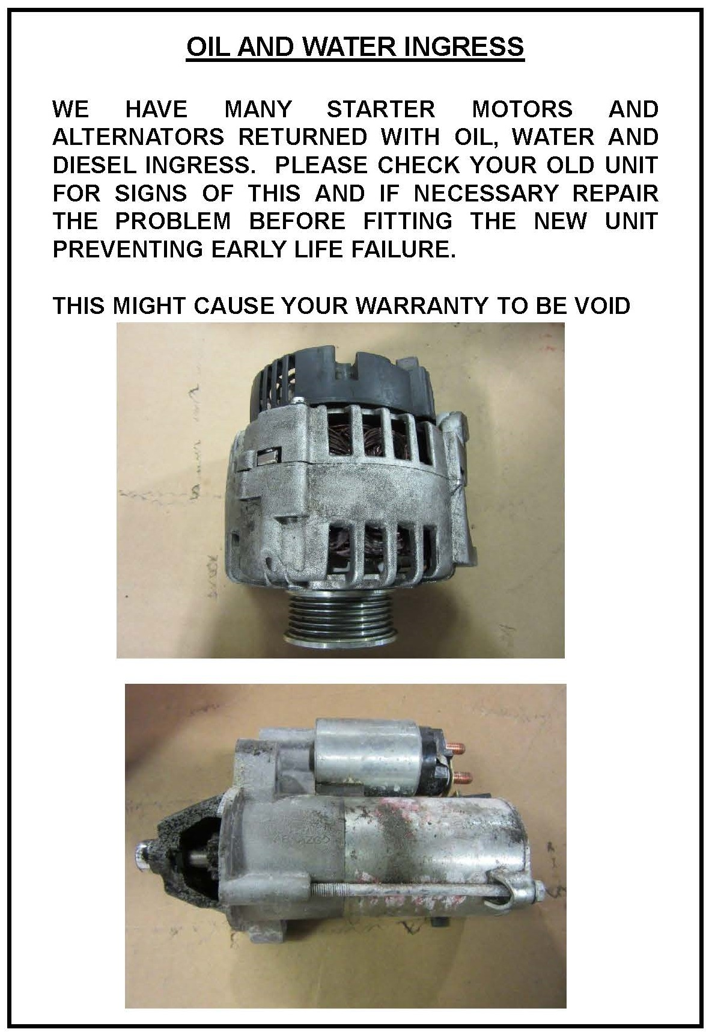*Rolling Components will not accept any faulty unit or dispatch any replacement against the faulty to third party or end user, on behalf of our customer

